**Fitness First Gym Management System**

Sem-4 eProject

**CERTIFICATE OF COMPLETION**

This is to acknowledge that the following persons participated in and have completed this Semester 4 eProject - **Fitness First Gym Management System**:

|  |  |
| --- | --- |
| **Student1522484** | **PRAISE CHIEMELA ESOCHAGHI** |
| **Student1520702** | **CHUKWUNONSO JOEL NKUMEH** |
| **Student1522341** | **BRIGHT NDUBUISI EZEABIA** |
| **Student1553970** | **JAMES ONYEDIKACHUKWU NWAKAEZE** |
| **Student1556044** | **PETER IBUCHI OBISI** |

**TABLE OF CONTENT**

ACKNOWLEDGEMENT 2

e-PROJECT SYNOPSIS 3

OBJECTIVE 4

e-PROJECT ANALYSIS 5

FLOWCHART 8

SCREENSHOTS 9

USER’S GUIDE 11

DEVELOPER’S GUIDE 13

CONCLUSION 15

# ACKNOWLEDGEMENT

We would like to use this opportunity to express our gratitude to God and acknowledge the hard work put in by each team member to ensure the successful completion of this project. We were able to complete the project more quickly and more effectively thanks to everyone's dedication and ability.

We express our gratitude to Aptech for granting us the opportunity to complete this project. It has provided us the ability to study and expand on the knowledge we have gained, enhance our coding and programming skills, and enable us to confidently state that we are capable of handling any project or issue in the world.

**e-PROJECT SYNOPSIS**

**Fitness First Gym Management System**

**Overview:**  
Fitness First Gym requires a comprehensive software solution to efficiently manage member records, memberships, class and trainer bookings, sales processing, and communication. The system is designed to streamline operations and enhance the overall member experience.

Designed for gyms of all sizes, this feature-rich software includes a complete booking system, point-of-sale functionality, website and billing integration, and online booking options for clients.

This system will improve gym operations by automating key tasks and ensuring seamless management.

System Modules

Guest Users:

View general information about the gym, including available facilities, trainers, and equipment.

Make inquiries through the "Contact Us" page.

Registered Users:

**Membership Application:** Users can browse and apply for gym packages.

**User Registration:** A one-time registration is required to access gym services.

**Login & Access:** Registered users can log in to apply for packages and manage their bookings.

**Booking History:** Users can view past and active bookings, along with payment details.

**Profile Management:** Users can update their personal information.

**Change Password:** Users can update their login credentials.

**Admin Panel**

The admin has full control over the system and can manage all functionalities via a secure login.

**Dashboard:** Provides an overview of gym bookings, listed packages, categories, and package types.

**Categories Management:** Admin can add or remove package categories.

**Package Types:** Admin can create and manage package types.

**Packages Management:** Admin can add, update, or remove gym packages.

**Bookings Management:** Admin can monitor new bookings, track payments (partial or full), and update payment details.

**Reports & Analytics:** Generates reports for bookings and registered users within a selected date range.

**Admin Profile Management:** The admin can update their profile, change passwords, and recover login credentials.

**Problem Definition**

Managing a gym efficiently requires handling multiple aspects, including member registrations, bookings, trainer schedules, payment processing, and communication. Traditional methods, such as manual record-keeping or fragmented digital tools, often lead to inefficiencies, errors, and poor customer experiences.

**Key Challenges:**

**Member Management:** Tracking memberships, renewals, and attendance manually is time-consuming and prone to errors.

**Booking System:** Managing class and trainer bookings without automation leads to scheduling conflicts.

**Payment Processing:** Handling membership payments and tracking dues manually increases the risk of errors and delayed payments.

**Communication:** Lack of a centralized system makes it difficult to notify members about updates, offers, or schedule changes.

**Sales and Reports:** Monitoring gym revenue, sales, and financial reports without an integrated system requires extra effort and time.

Proposed Solution

The Fitness First Gym Management System will address these challenges by providing a centralized platform to automate membership management, online bookings, trainer schedules, payment processing, and reporting. This will enhance efficiency, accuracy, and user experience, ensuring smooth gym operations.

**Customer Requirement Specification (CRS)**

The **Fitness First Gym Management System** is designed to meet the specific needs of gym owners, administrators, trainers, and members by providing a **user-friendly, automated, and efficient** solution for gym operations. The system will include the following functional and non-functional requirements:

1. Functional Requirements

**Guest Users:**

Can view general information about the gym, trainers, and available equipment.

Can inquire about services through the **Contact Us** page.

**Registered Users (Members):**

Can **register** and create an account to access gym services.

Can **log in** to their account securely.

Can **apply for gym packages** and make payments.

Can **book trainers and classes** online.

Can view their **booking history** and payment details.

Can **update profile details** (except certain restricted fields).

Can **change their password** when needed.

Trainers (If Applicable):

Can log in to their **trainer dashboard**.

Can view and manage their **schedules and appointments**.

Can update their **specialization and availability**.

**Admin:**

Has full control over the system and can log in via the admin panel.

**Dashboard:** Displays an overview of bookings, members, payments, and revenue.

**Categories Management:** Add, edit, and delete gym service categories.

**Package Management:** Create and modify gym membership packages.

**Trainer Management:** Add, assign, or remove trainers (if applicable).

**Bookings & Payments:** View, approve, or manage new bookings and track payments (full or partial).

**Reporting & Analytics:** Generate reports for bookings, revenue, and registered users.

**User Management:** Manage and verify registered users.

Can **update profile, change password, and recover password** if needed.

**2. Non-Functional Requirements:**

**User-Friendly Interface:** The system should have an intuitive and responsive design.

**Scalability:** Must be able to handle an increasing number of users, bookings, and payments.

**Security:** Ensure data protection with secure login, encrypted transactions, and role-based access.

**Payment Gateway Integration:** Secure payment processing using **Paystack**.

**Performance:** The system should provide quick response times and seamless navigation.

Cross-Platform Accessibility: Accessible via web browsers and mobile devices.

This specification ensures that the Fitness First Gym Management System meets customer expectations while enhancing operational efficiency and user experience.

**Project Plan (2 Weeks)**

Week 1: Development & Implementation

**Day 1-2:** System architecture planning and database design

**Day 3-4:** User authentication (registration, login, and role-based access)

**Day 5-6:** Booking system development (packages, trainers, and classes)

**Day 7:** Payment gateway (Paystack) integration

Week 2: Testing, Deployment & Documentation

**Day 8-9: Testing and bug fixes (functional & UI testing)**

**Day 10-11: Admin dashboard and report generation**

**Day 12: Final adjustments and deployment to hosting platform**

**Day 13-14: Documentation preparation and final review for submission**

**Diagram**

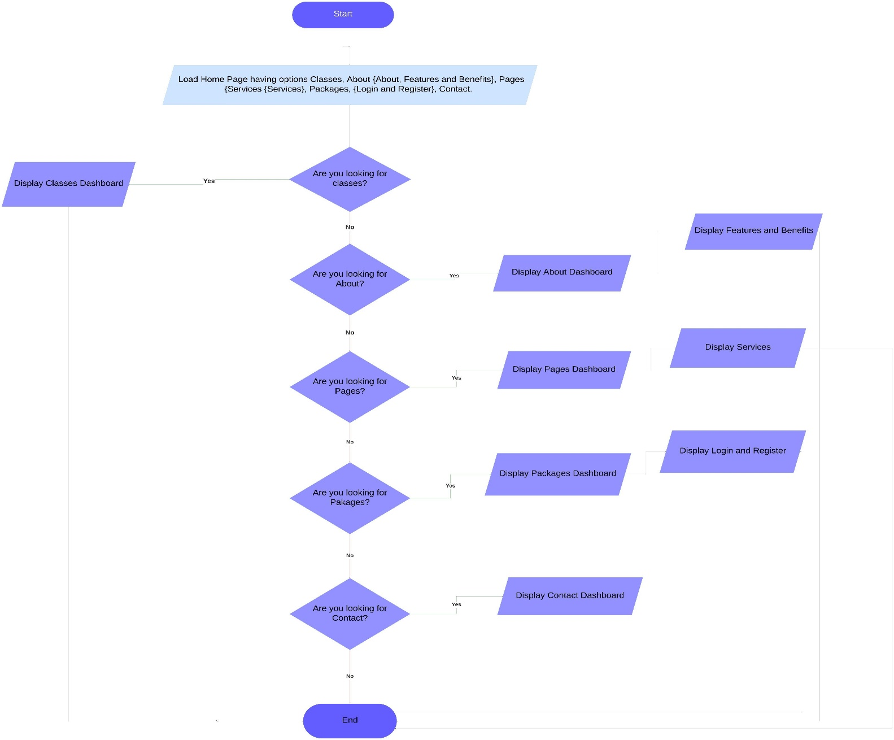

**Algorithms Used in the Gym Management System**

User Authentication Algorithm

Purpose: **To securely handle user registration and login.**

Steps:

**User inputs email, username, and password.**

**System checks if the email/username is unique.**

**Password is hashed and stored securely.**

**During login, the input password is hashed and compared with the stored hash.**

**If matched, the user is authenticated and given access based on role (Admin/User).**

Booking Algorithm

Purpose: **To allow users to book gym packages and trainers.**

Steps:

**User selects a package and trainer (if applicable).**

**System checks availability based on trainer schedule and package capacity.**

**If available, booking is confirmed, and payment is processed.**

**System updates the booking status (Pending, Confirmed, or Cancelled).**

Payment Processing Algorithm (Paystack Integration)

Purpose: **To handle online transactions.**

Steps:

**User selects a package and initiates payment.**

**System generates a payment request via Paystack API.**

**User completes payment on Paystack.**

**Paystack verifies payment and sends confirmation to the system.**

**If successful, booking status updates to "Paid"; otherwise, remains "Pending."**

Trainer Scheduling Algorithm

Purpose: **To prevent double-booking of trainers.**

Steps:

**When a user selects a trainer, the system fetches their availability.**

**If a trainer is booked for the selected time slot, the system suggests an alternative.**

**If available, booking is confirmed and stored in the database.**

Admin Report Generation Algorithm

Purpose: **To generate reports for bookings, revenue, and registered users.**

Steps:

**Admin selects a date range for the report.**

**System fetches relevant data from the database.**

**Data is formatted into tables/charts for easy visualization.**

**Reports can be exported as PDFs or viewed in the dashboard.**

**GUI STANDARDS DOCUMENT / INTERFACE DESING DOCUMENTS**

**Note:** The **Developer’s Guide** is located in the same directory as this documentation. It contains detailed explanations of the code, including system architecture, and implementation details. Developers should refer to it for a deeper understanding of how the system functions. Name developers-guide.html

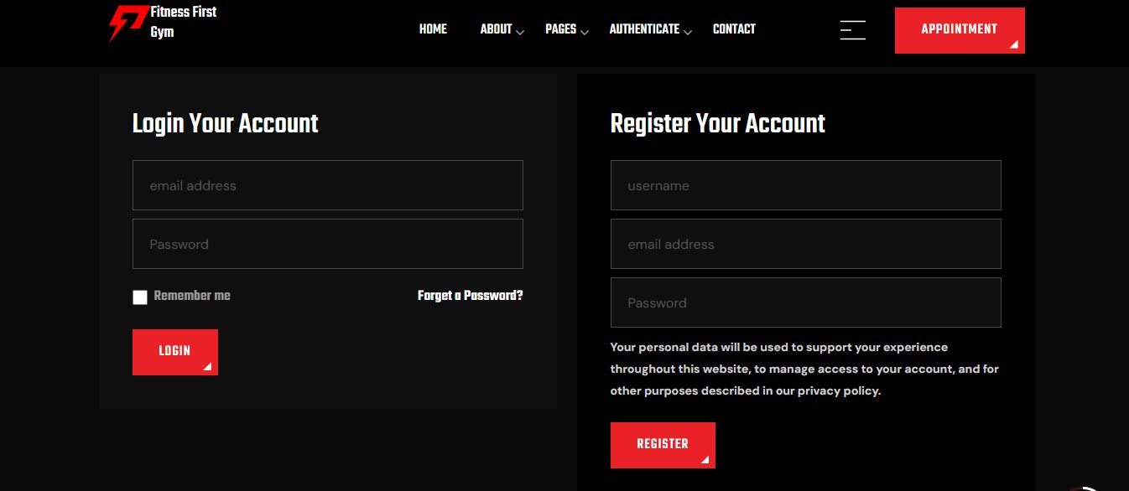PICTURES OF THE GUI BELOW:

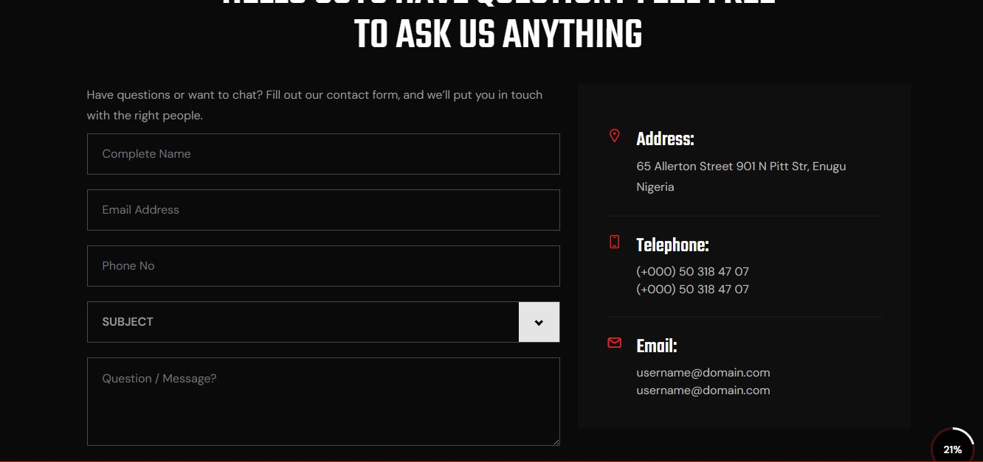ABOUT US PAGE WITH ACTIVE FORM FOR QUICK ACTION

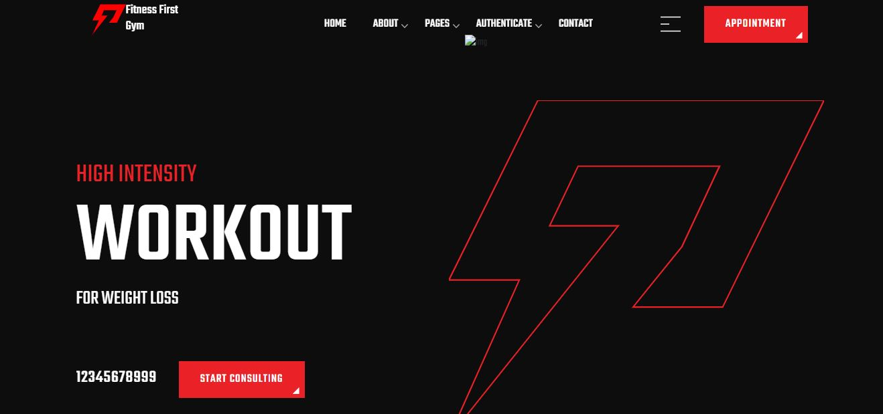HOME PAGE WITH RESPONSIVE NAVBAR

# ****Unit Testing Checklist****

### **Module: User Management**

✔ User registration (email, username, and full name validation)  
✔ Login authentication with encrypted passwords  
✔ Password reset and change password functionality

### **Module: Booking System**

✔ Package selection and booking functionality  
✔ Booking confirmation and history retrieval  
✔ Payment processing via Paystack integration

### **Module: Admin Dashboard**

✔ View, approve, and manage bookings  
✔ Add, edit, and delete gym packages  
✔ Generate reports on bookings and users

### **Module: Payment Processing**

✔ Successful transaction processing via Paystack  
✔ Handling of failed or incomplete payments  
✔ Refund and payment status updates

### **Module: Security & Authorization**

✔ User authentication and session management  
✔ Role-based access control for users and admin  
✔ Protection against SQL Injection & CSRF

# ****Final Checklist****

### **1. Functional Requirements**

✔ User registration and login works correctly  
✔ Booking and payment system functions as expected  
✔ Admin dashboard allows management of users, bookings, and payments

### **2. Performance & Security**

✔ System tested for response time and load handling  
✔ User data securely stored with encryption  
✔ Payment transactions are secured

### **3. User Interface & Experience**

✔ Navigation is intuitive and responsive  
✔ Forms and buttons work across devices  
✔ Error messages and validations are clear

### **4. Deployment & Documentation**

✔ The system is hosted and accessible online  
✔ Documentation for installation and usage is complete  
✔ Project report includes all required details